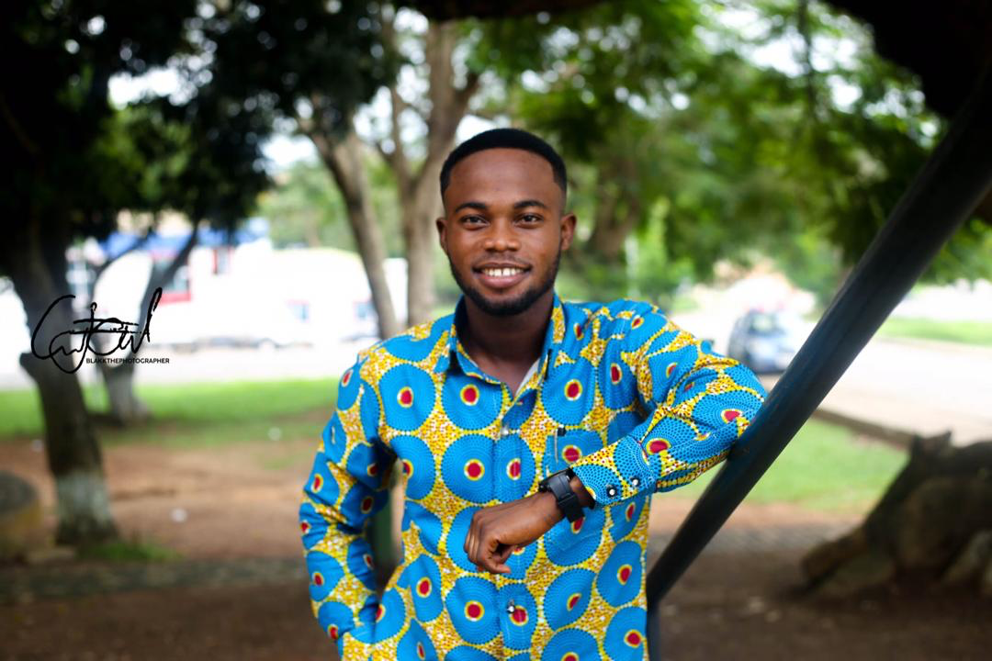

COMPILED BY: Duah Ahenkorah Louis (TEAM O’NEAL)

0550646915

Let’s make it together.✊✊✊

Wishing a merry Christmas and a prosperous new year!

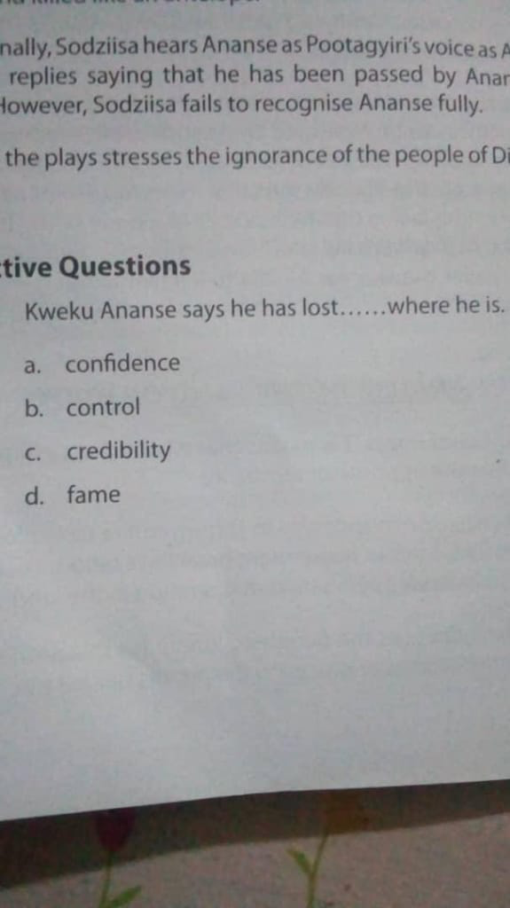

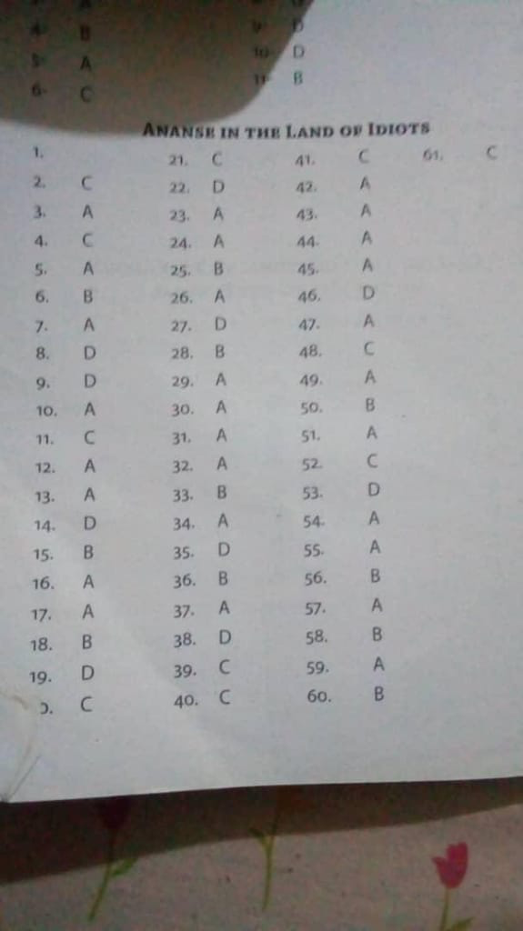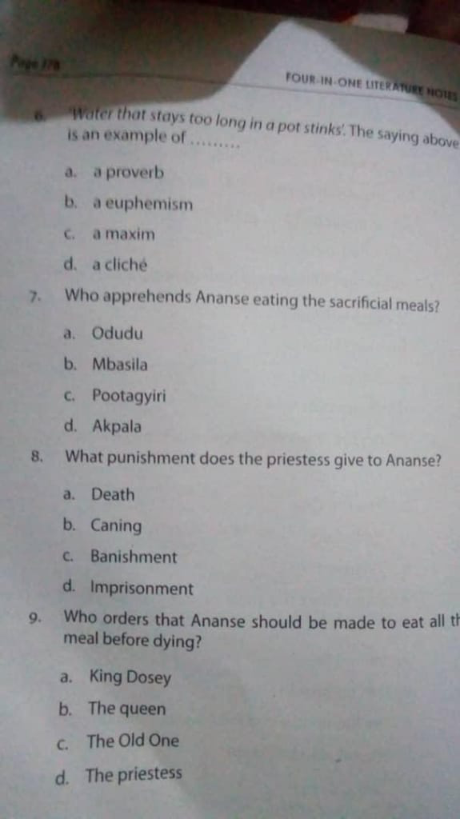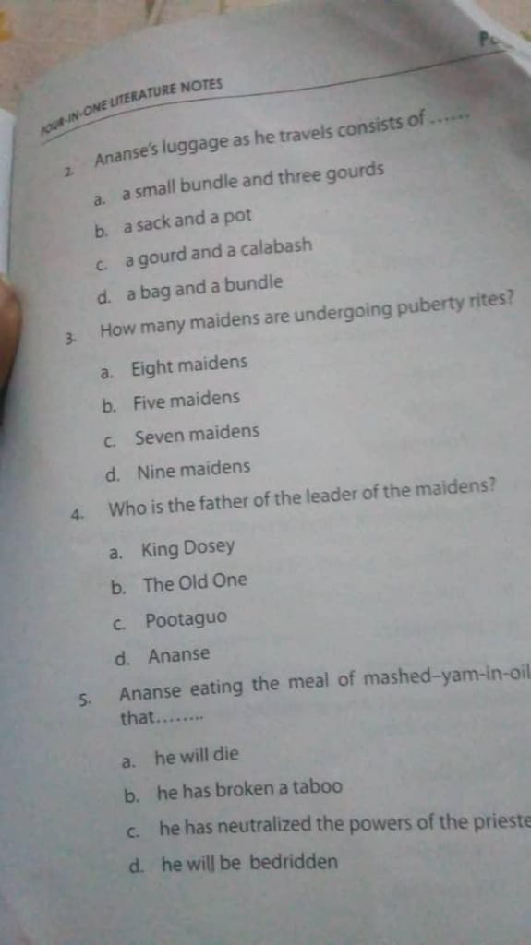

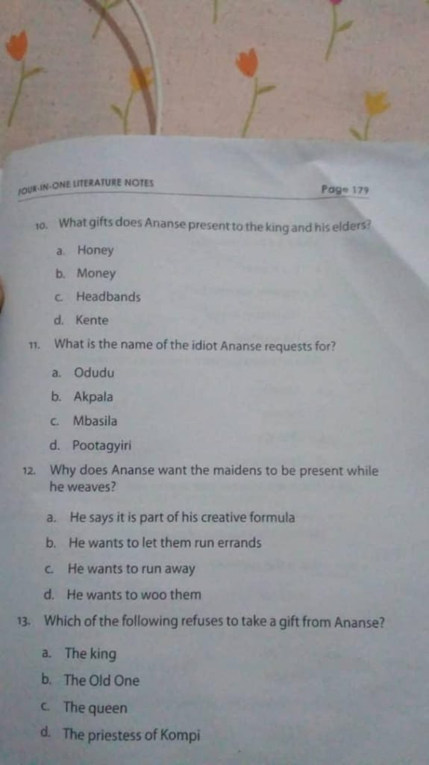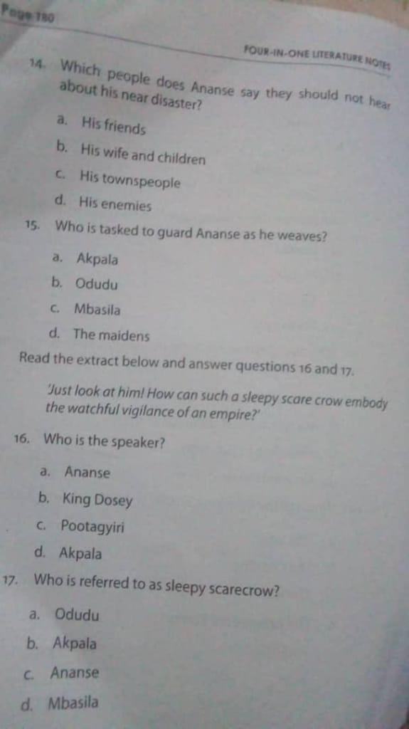

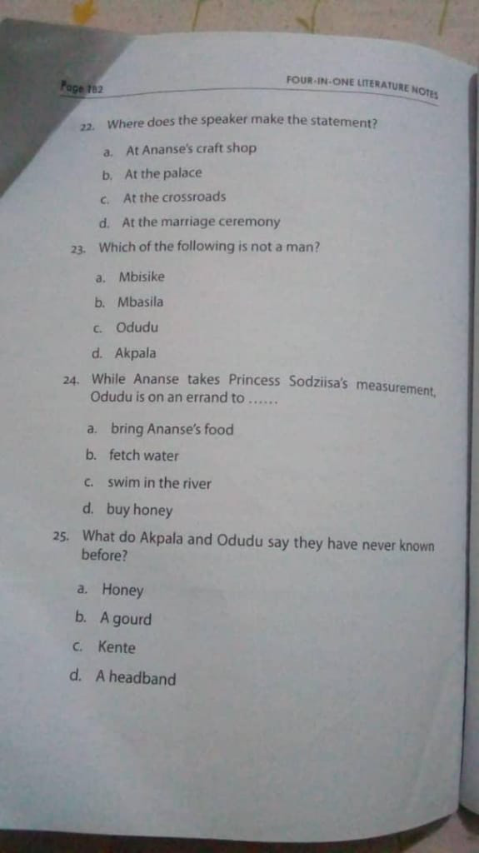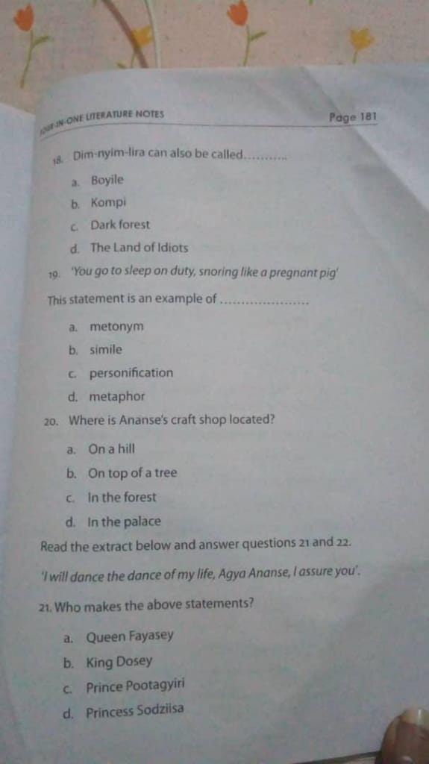COMPILED BY: Duah Ahenkorah Louis (TEAM O’NEAL)

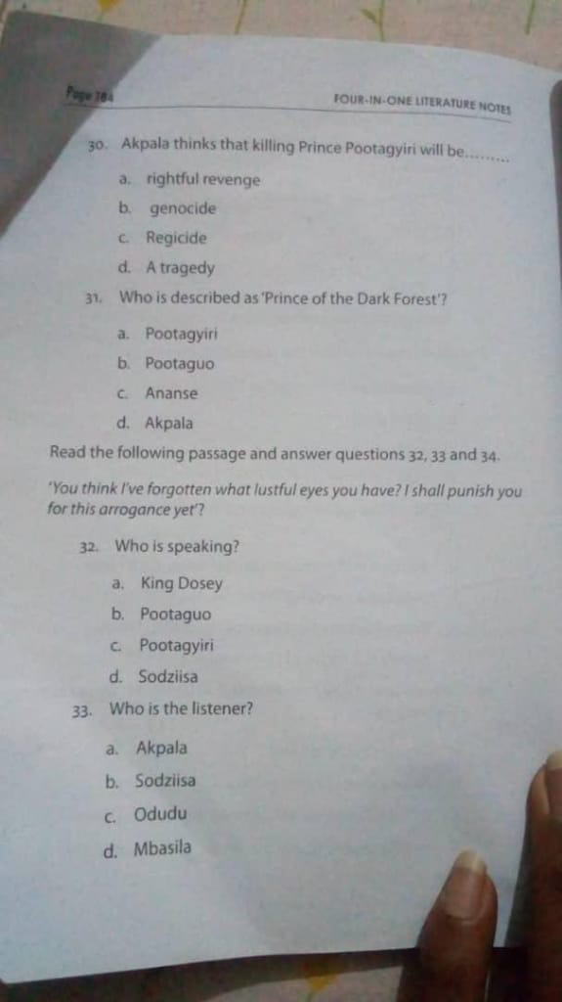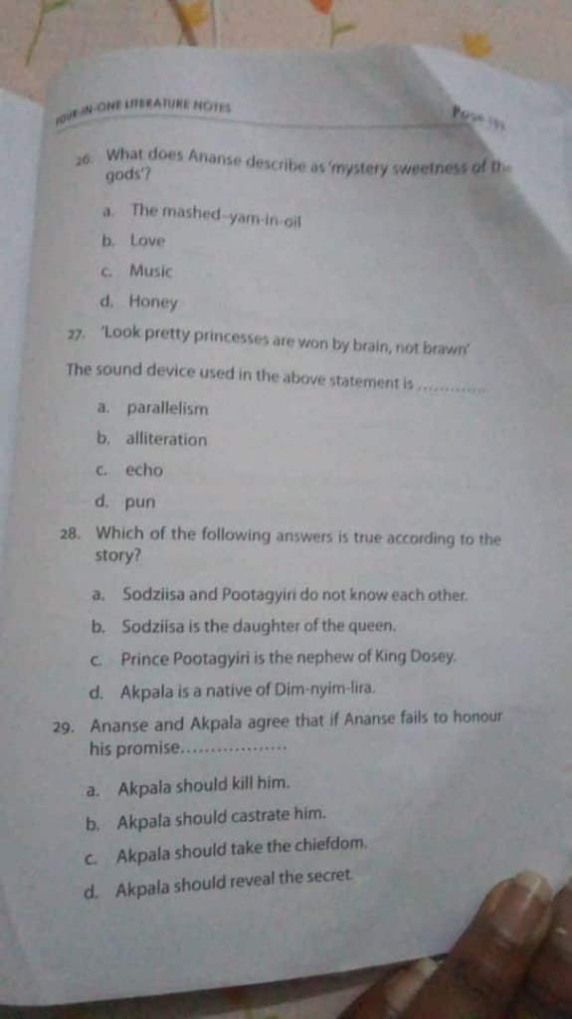

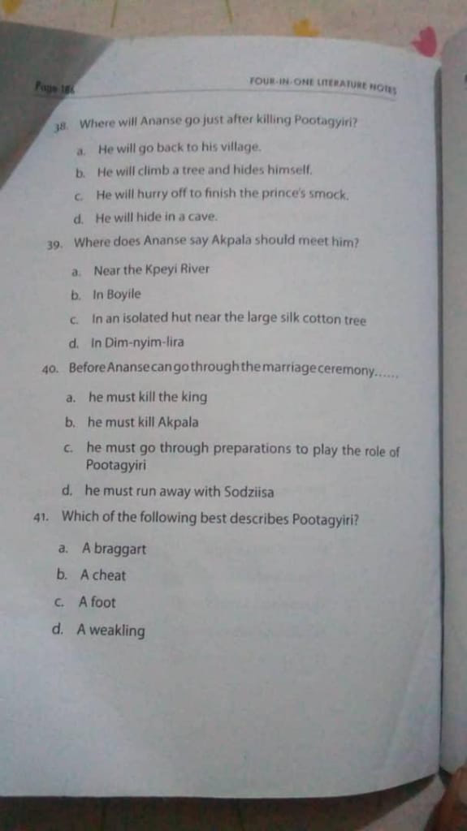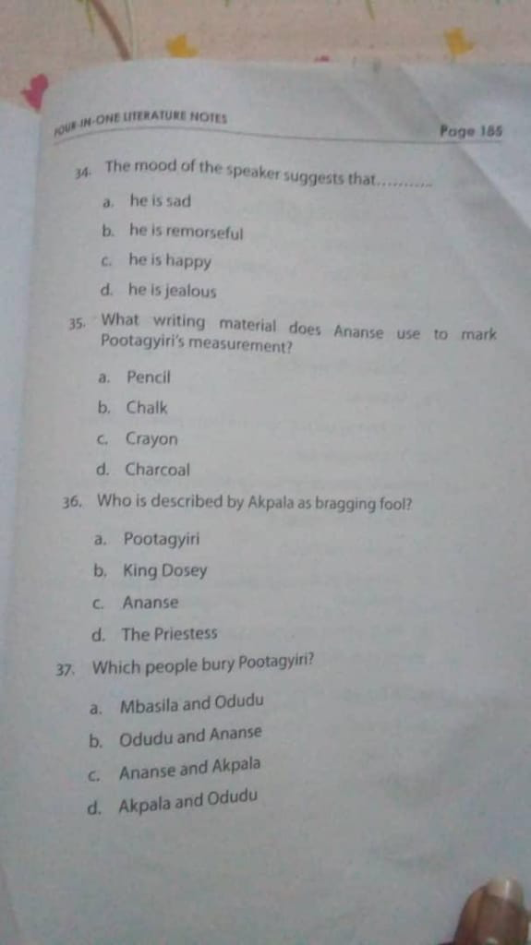

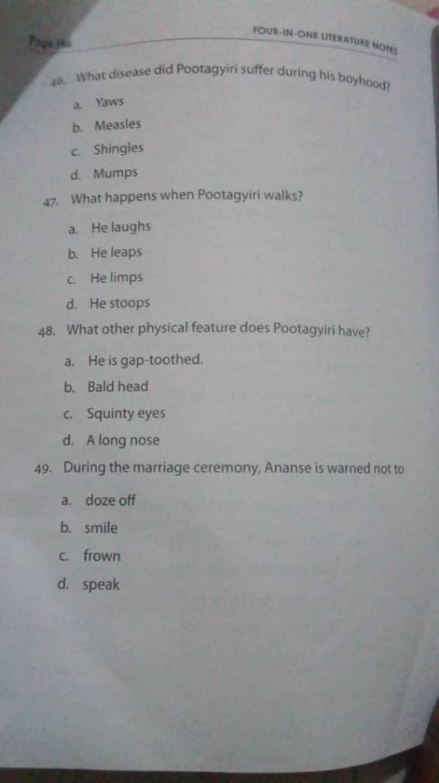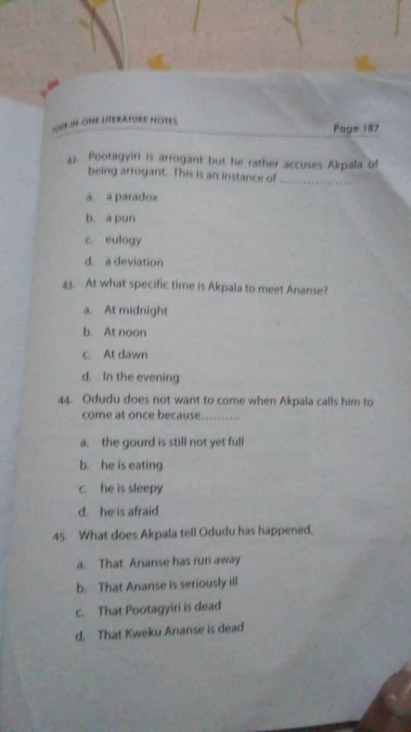COMPILED BY: Duah Ahenkorah Louis (TEAM O’NEAL)

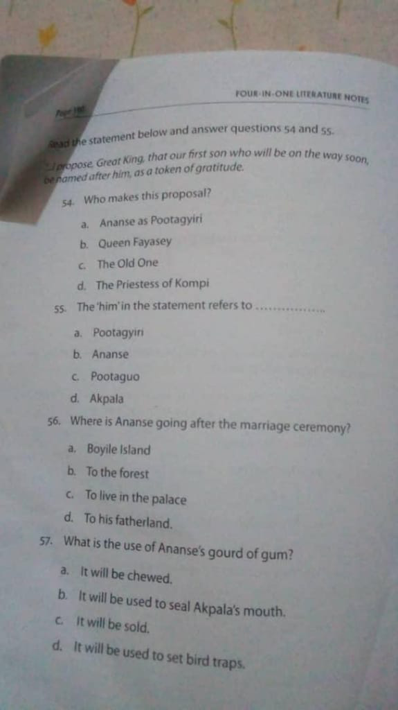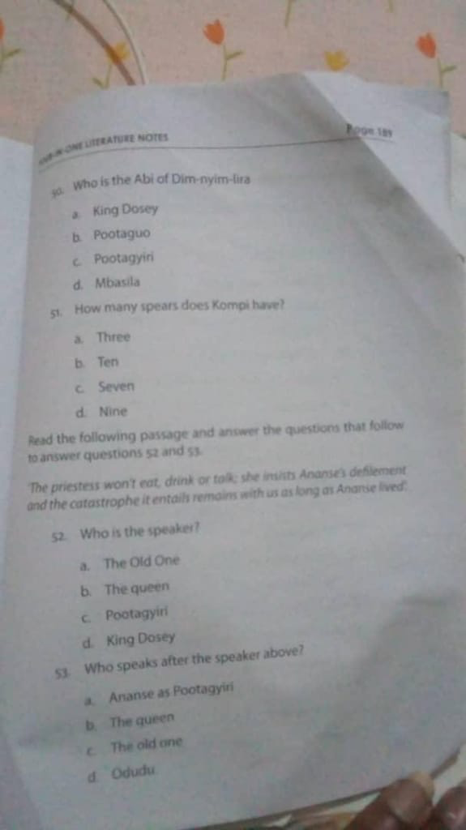COMPILED BY: Duah Ahenkorah Louis (TEAM O’NEAL)

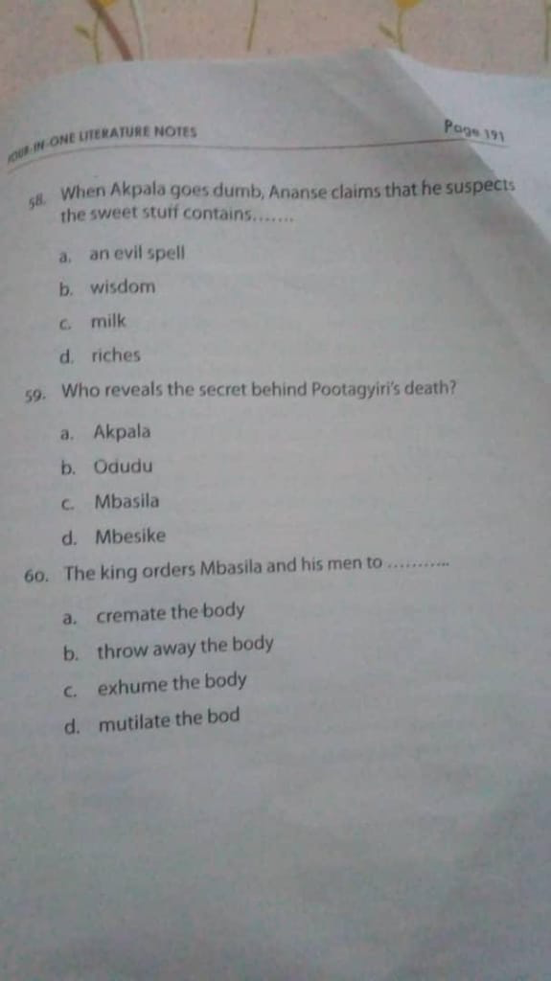COMPILED BY: Duah Ahenkorah Louis ( TEAM O’NEAL )



COMPILED BY: Duah Ahenkorah Louis (TEAM O’NEAL)

0550646915

Wishing you a merry Christmas and a prosperous new year!